NAT Gateway:

Scenario:

* I have a VPC
* Two subnets ( one public (s1) , one private (s2))
* One Ec2 instance in each subnet
  + EC2 in public - machine 1
  + EC2 in private - machine 2

Subnet 1:

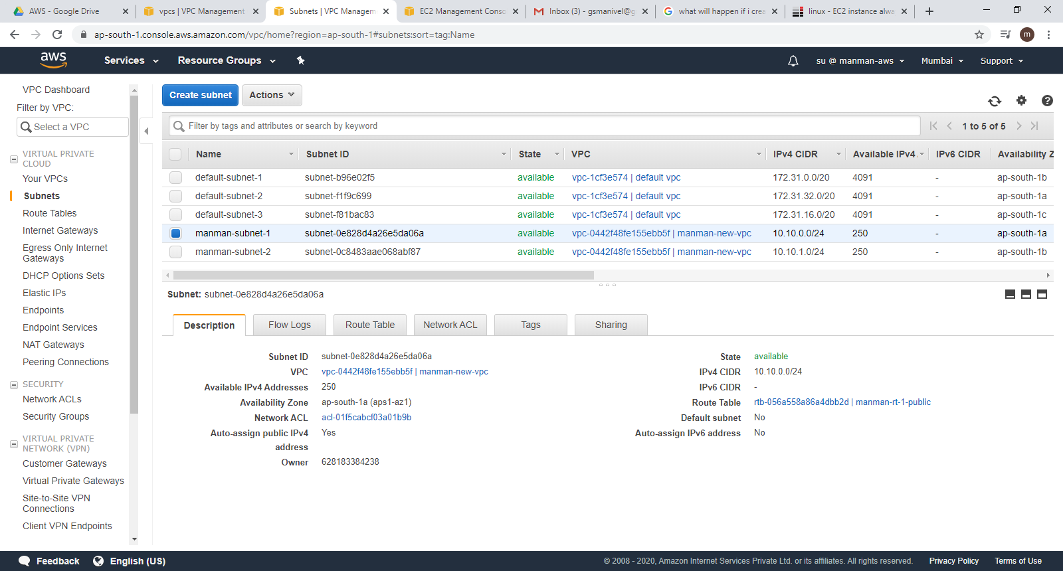

Subnet2:

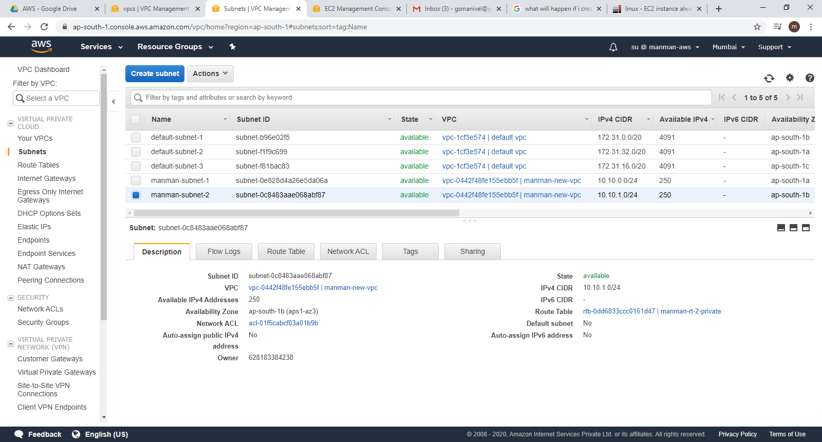

Situation is :

**Machine -1 :**

I am able to connect to internet using machine 1 because

Machine 1 is in public subnet

VPC has IGW

Route table is configured to access IGW

Machine 1 is enabled to assign public ip address

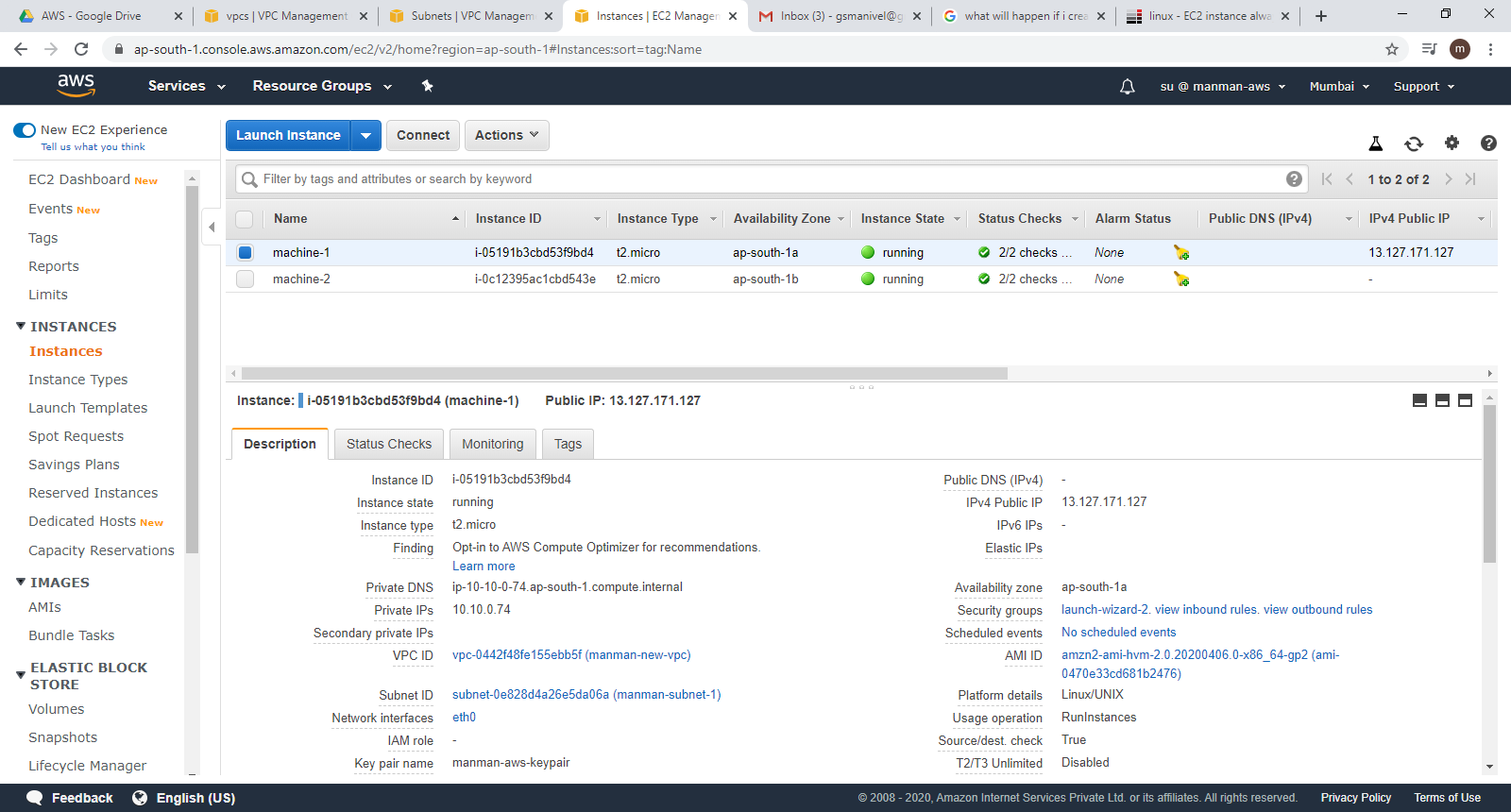

Machine -2:

I am in private subnet with only private ip address

I don't have connection with IGW

Security group is configured such that any machine in this VPC ( machine 1 as well) can connect me , ping me

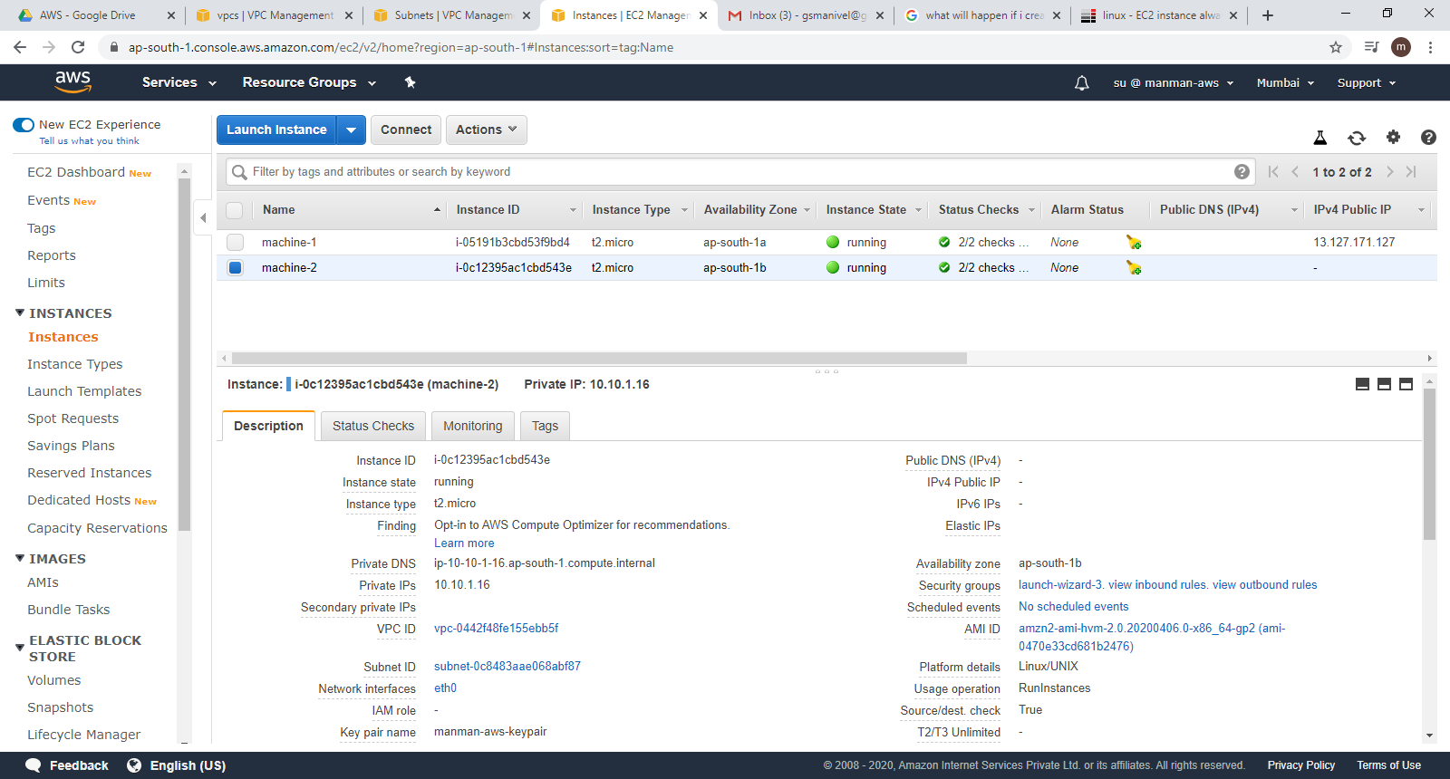

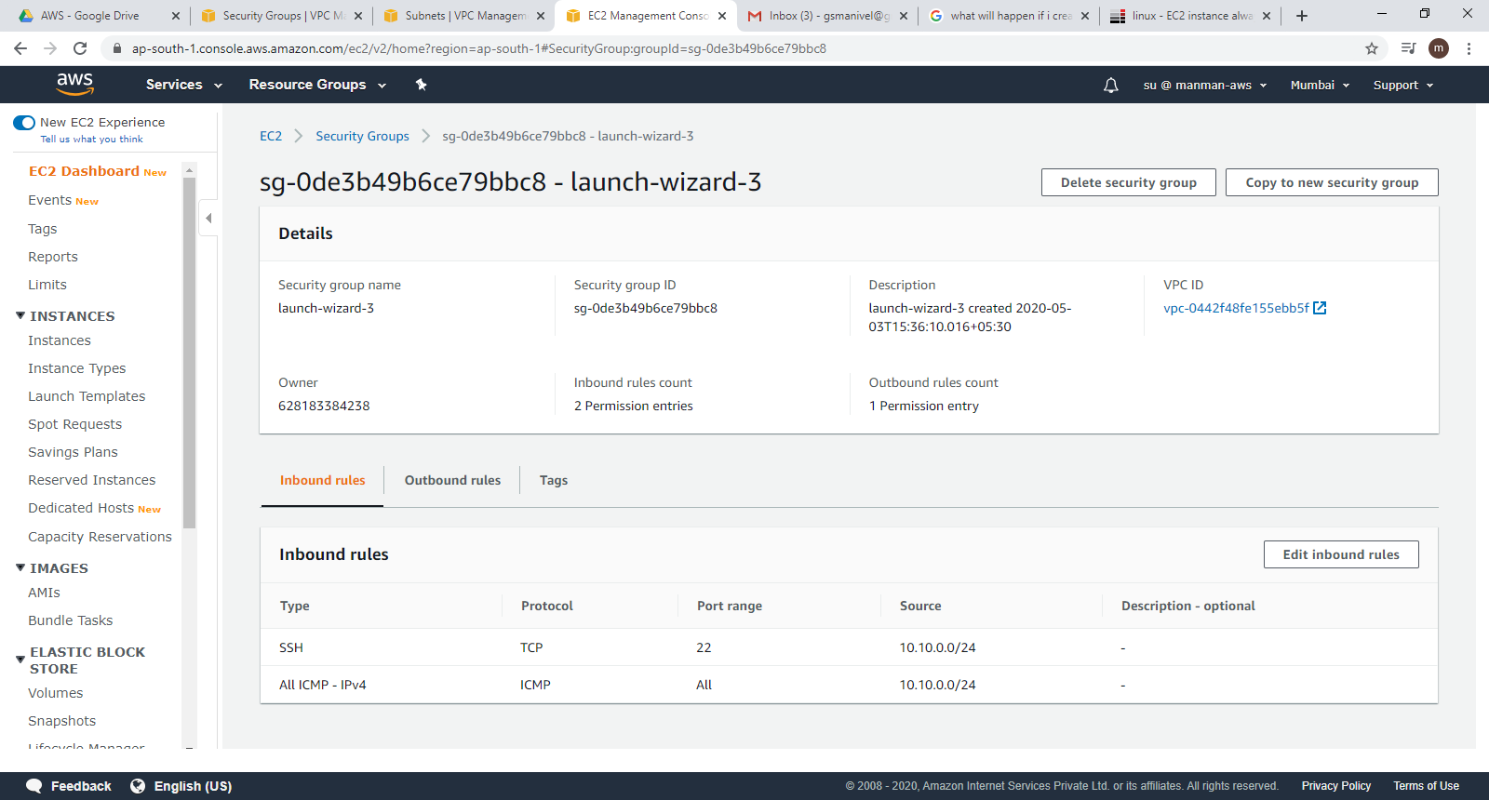

Ask is:

Ssh to machine 1 from your windows machine.

Then ssh to machine 2 from machine 1

Try to access google.com

Actual result would be : machine 2 is private subnet. Hence internet can not be accessed

Now,

Add a NAT gatway in the same VPC (in public subnet)

Modify the machine 2 route table to redirect to NAT gatway

Now- Ask is

Ssh to machine 1 from your windows machine.

Then ssh to machine 2 from machine 1

Try to access google.com

Actual :

We are able to connect machine 2 using machine 1 and able to connect to internet using nat gatway

